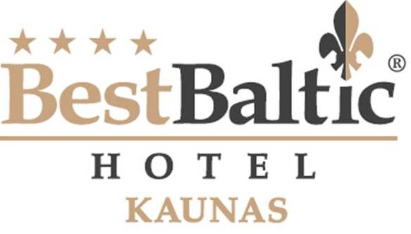
BEST BALTIC Kaunas
A. Mickeviciaus g. 28, Kaunas
Tel.: +370 37 321505
E-mail: kaunas@bestbaltichotels.eu

HOTEL RESERVATION FORM

For the participants of IFA CONGRESS 2016
Kaunas, Lithuania

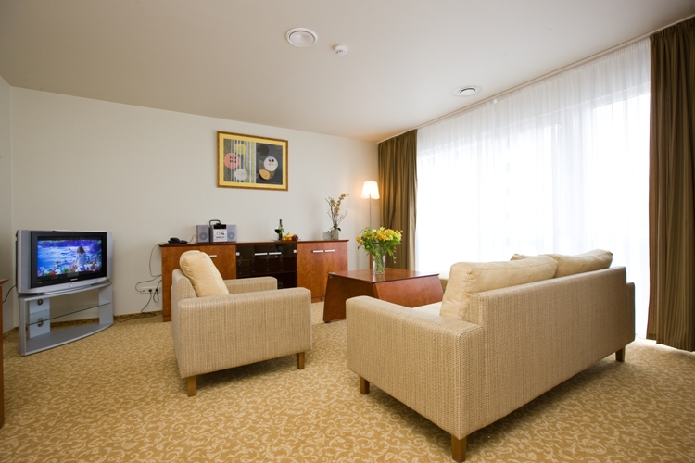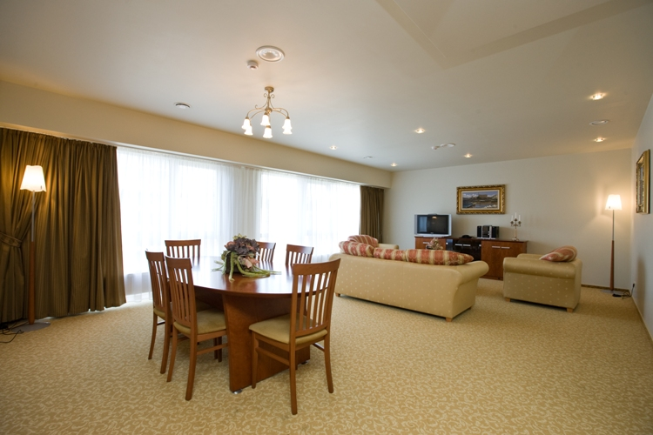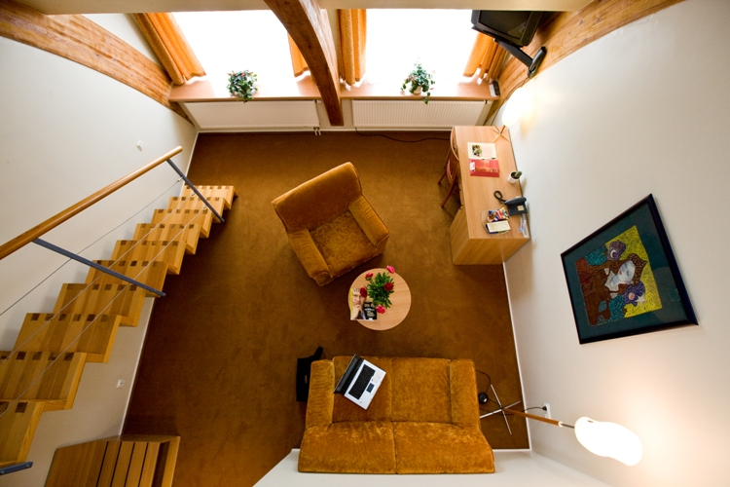

LAST NAME:
FIRST NAME:
ADDRESS:
PHONE :
E-MAIL:
ARRIVAL DATE:
DEPARTURE DATE:

ROOM TYPE | RATE | PLEASE CHOOSE ROOM TYPE | PLEASE SPECIFY NO. OF ROOMS
STANDARD SINGLE | 68 EUR
STANDARD DOUBLE OR TWIN | 78 EUR
DELUXE SINGLE | 88 EUR
DELIXE DOUBLE OR TWIN | 100 EUR
SPECIAL NOTES / REQUESTS:
please indicate all food allergies and intolerances

Room rate includes full breakfast, sauna and swimming pool (from 7:00 till 10:00 a.m.), use of business center (computer, printer, fax), Wi-Fi access, car parking place and VAT.
The city tax – per person from 18 years old - 0.50 EUR per person and night (this fee is not included into the room rate).

- Check-in starts from 14:00; check-out until 12:00.
- Guaranteed reservation can be cancelled without any charge 24 hours before arrival date.
- In case of NO SHOW without any warning, the Hotel charges 100% of room rate per night.
- Please note that this form does not guarantee a reservation. Reservations will be confirmed upon availability.

WE KINDLY ASK YOU TO SEND US YOUR CREDIT CARD INFO TO GUARANTEE THE RESERVATION:
VISA American Express Eurocard/Mastercard
Number: Expiry date:
PLEASE MARK IF YOU NEED TRANSFER SERVICE: Yes No
Vilnius airport – Hotel (79 EUR) Kaunas airport – Hotel (18 EUR)
Please provide flight details: Arrival time Flight number

PLEASE SEND US THIS FORM BY FAX +370 37 321632 OR E-MAIL kaunas@bestbaltichotels.eu
Visit our website for more information about the hotel: www.bestbaltichotels.eu

CHOOSE THE BEST!

